LaCie 10TB 1big Dock

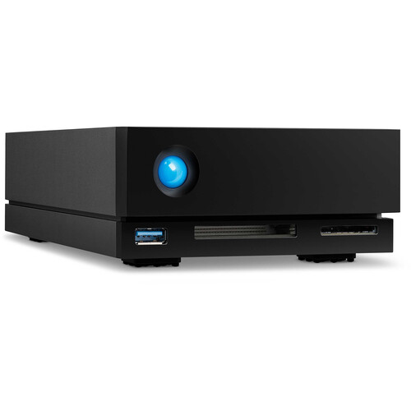

**Key Features**

* **10TB Storage Capacity**: With 10 terabytes of storage, this drive provides ample space for video editors, photographers, and designers to store large projects, backups, and data archives.
* **Integrated Docking Station**: The LaCie 1big Dock comes with a built-in docking station that offers additional I/O ports (USB, SD, and CF card readers, etc.), providing users with an all-in-one solution for managing storage and media peripherals.
* **USB 3.1 Gen 2 (USB-C) Interface**: It offers fast data transfer speeds with USB 3.1 Gen 2 (up to 10Gbps) and features a USB-C connection, making it compatible with modern laptops and desktop computers, including both Mac and Windows systems.

**Performance**

* **7200 RPM HDD**: The internal 7200 RPM hard drive provides a good balance between capacity and speed, offering decent read/write speeds, which are sufficient for most video editing, media production, and file storage tasks.

**Warranty and Support**

* **Limited 5-Year Warranty**: The LaCie 1big Dock comes with a 5-year warranty, which ensures reliability for professional users who rely on it for mission-critical tasks.
* **Data Recovery Service**: LaCie provides a one-year Rescue Data Recovery Service, giving users peace of mind in case of unexpected data loss.